STOCK MARKET ANALYSIS

SQL PROJECT

### BY -

Saurabh Kumar Soni

# CONTENTS

* Introduction to Case Study
* Objective
* Data Analysis
* Insights

# CASE STUDY

* [Data Source https://www.kaggle.com/datasets/debashis74017/stock-market-index-data- india-1990-2022?rvi=1](https://www.kaggle.com/datasets/debashis74017/stock-market-index-data-india-1990-2022?rvi=1)
* This Case Study contains 3 Datasets.
* Attributes(Same in all 3 Datasets) – Date, Open, High, Close, Sector.
* Data in Dataset is from 2011-08-01 To 2022-01-31.
* 1st Dataset - Nifty IT Dataset.
* 2nd Dataset - Nifty FMCG Dataset.
* 3rd Dataset - Nifty BANK Dataset.

# OBJECTIVE

* Analyse IT Industry, FMCG Industry and BANK Industry on following parameters -
  + Volatility.
  + Drawdown percentage (Time Frame – 2020-02-20 and 2020-03-23).
  + Recovery days.
  + Number of days when price closed above its previous day’s close.
  + CAGR(Returns).
  + Scoring based on the above criteria.

# IT INDUSTRY

* The **IT** sector is a field which is changing the shape of Indian business standards.
* This sector includes –
  + software development, consultancies, software management.
  + online services and business process outsourcing (BPO).
* The IT industry accounted for 7.4% of India’s GDP in FY22, and it is expected to contribute 10% to India’s GDP by 2025.



# FMCG INDUSTRY

* The Fast-moving consumer goods (FMCG) sector is the 4th largest sector of the [Indian economy](https://www.investindia.gov.in/team-india-blogs/indian-economy-overview).
* Fast-moving consumer goods are nondurable products that sell quickly at relatively low costs.
* FMCGs have low profit margins and high-volume sales.
* Examples of FMCGs include milk, gum, fruit and vegetables etc.



# BANK INDUSTRY

* Banking is an industry that deals with credit facilities, storage for cash, investments, and other financial transactions.
* A bank is an institution that accepts customer deposits and offers loans to individuals and corporate

clients.

* 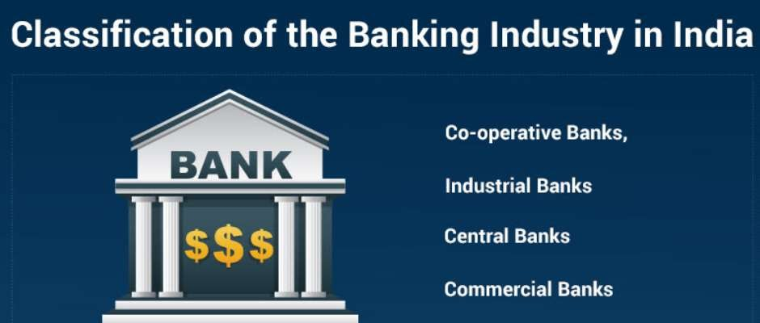The banking industry is one of the key drivers of most economies because it channels funds to borrowers with productive investments.

# DATA ANALYSIS

* **Data analysis** is the process of inspecting, [cleansing](https://en.wikipedia.org/wiki/Data_cleansing), [transforming](https://en.wikipedia.org/wiki/Data_transformation),

and [modeling](https://en.wikipedia.org/wiki/Data_modeling) [data](https://en.wikipedia.org/wiki/Data) with the goal of discovering useful information, informing

conclusions, and supporting decision-making.

* The process of data analysis uses to organize the data in a logical way. It helps to analyze data from different outlooks and a variety of statistical perspectives.



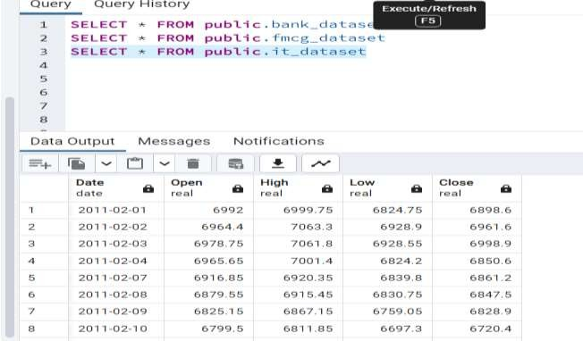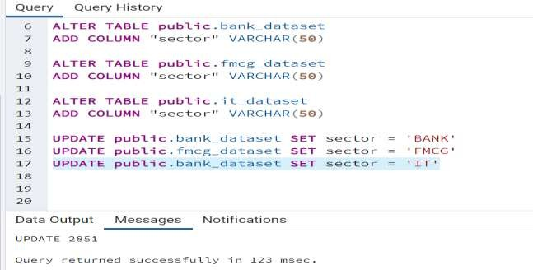

* Retrieving data from the table.
* Adding a new column sector.

### VOLATILITY –

– In finance , Volatility is the rate at which the price of a



Volatility

stock increases or decreases over a particular period.

Higher stock price volatility often means higher risk and helps an investor to estimate the fluctuations that may happen in the future.

Formula Used – Average(Day High – Day Low) over a period of time.

INSIGHTS -

Volatility – Lower is the better

IT is the least volatile sector

Banking sector is the most volatile sector

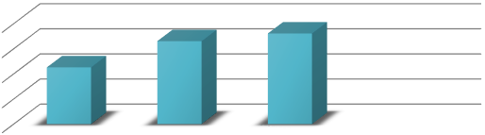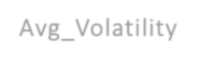

Avg_Volatility

360.971

400

300

200

100

0

330.392

226.014

Avg_Volatility

IT FMCG BANK

Avg_Volatility

## Volatility

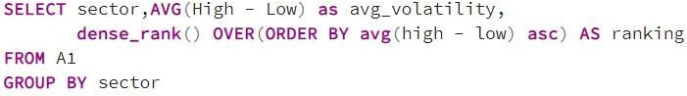

### DRAWDOWN (FALL IN PRICE) –

INSIGHTS -

(2020-02-20 to 2020-03-23)

– A drawdown is defined as the percentage of decline in the value over a period before it bounces back to the original value or beyond. It is expressed as the difference between the highest, i.e., the peak and the lowest.



Drawdown

Drawdown – Lower is the better

FMCG is the least Drawdown sector

Formula Used –

Percent Increase =

Final Value – Initial Value

Initial Value

× 100 %

Banking is the most Drawdown sector

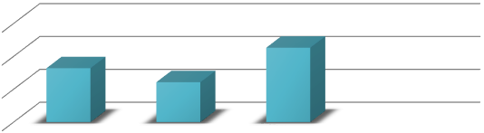

Drawdown (%)

60

45.325

40

32.853

24.325

20

Drawdown (%)

0

IT

FMCG

BANK

Drawdown (%)

### IT Drawdown





 ➢ FMCG Drawdown

 

### Bank Drawdown



RECOVERY DAYS–

Recovery Days – Number of days has to taken to close above it’s pre covid price.

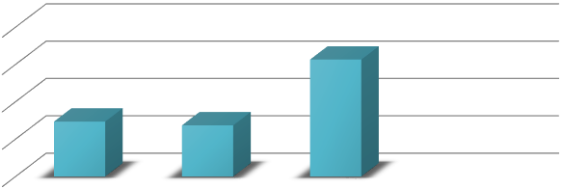

Recovery Days

400

313

300

200

147

137

100

Recovery Days

0

IT

FMCG

BANK

Recovery Days

INSIGHTS -

Recovery Days – Lesser the better

FMCG – Fastest Recovery Banking - Slowest Recovery

### IT Recovery Days



* FMCG Recovery Days



### BANK Recovery Days



NUMBER OF DAYS WHEN STOCK PRICE CLOSED ABOVE ITS PREVIOUS DAY CLOSED PRICE (STRENGTH)–

INSIGHTS -

Strength– Higher the better

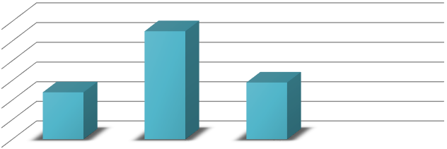

Strength

1530

1520

1510

1500

1490

1480

1470

1525

1499

1494

Strength

IT

FMCG

BANK

Strength

IT – minimum FMCG - maximum

## Strength

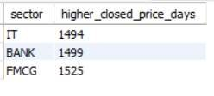

CAGR (COMPOUNDED ANNUAL GROWTH RATE)–

CAGR– The compounded annual growth rate (CAGR) is the rate of return (RoR) that would be required for an investment to grow from its beginning to its ending balance, assuming the profit ware reinvested at the end of each specific period of the investment’s life plan.



INSIGHTS -

CAGR– Higher the better

Bank – Lowest



CAGR =



Formula Used –

− 1 × 100

FMCG - Highest

Where, EV = Ending value, BV = Beginning value, n = Number of years



𝐸𝑉

𝐵𝑣

1

𝑛

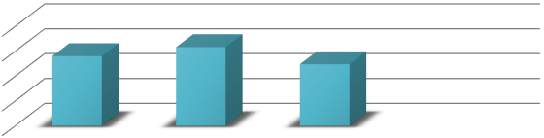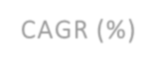

CAGR (%)

20

15

10

5

0

14.023

15.825

12.396

CAGR (%)

IT FMCG BANK

CAGR (%)

* 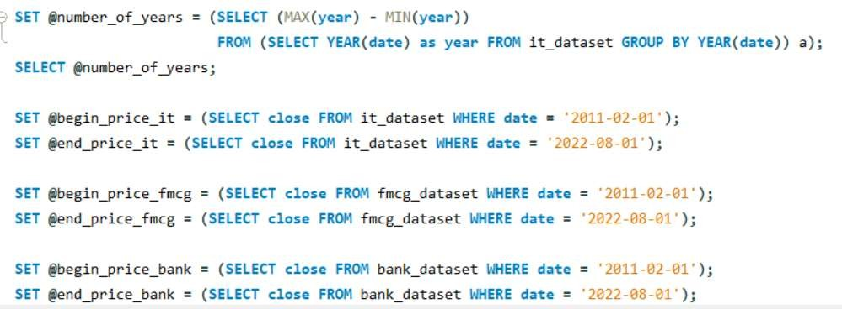CAGR Return.

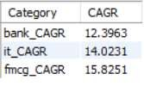

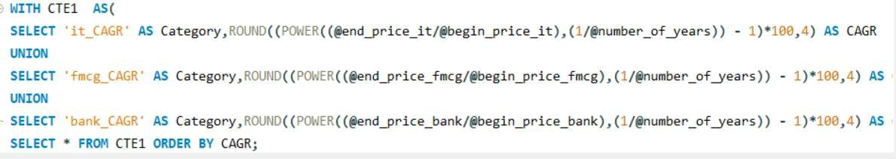

# WEIGHTAGES AND FINAL SCORE

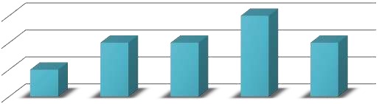

Weightage

30%

30%

20%

20%

20%

20%

10%

10%

0%

Weightage

Volatility Drawdown Recovery Strength CAGR

Weightage

Weightages Individual Score

|  |  |
| --- | --- |
| Description | Weightage |
| Volatility | 10% |
| Drawdown | 20% |
| Recovery | 20% |
| Higher_close_above | 30% |
| CAGR | 20% |

|  |  |  |  |  |  |
| --- | --- | --- | --- | --- | --- |
| Sector | Volatility | Drawdown | Recovery | Higher_close_a  bove | CAGR |
| IT | 3 | 2 | 2 | 1 | 2 |
| FMCG | 2 | 3 | 3 | 3 | 3 |
| BANK | 1 | 1 | 1 | 2 | 1 |

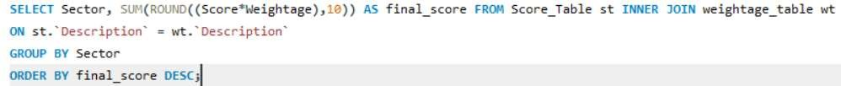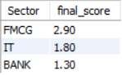

* 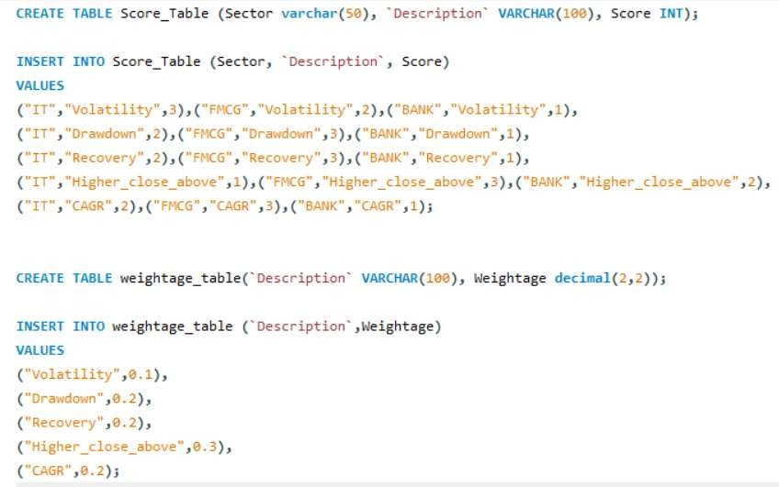Final Score

Final Score

3

2.5

2

1.5

1

0.5

0

1.8

2.9

1.3

Final Score

IT FMCG BANK

Conclusion -

Final Score

After careful consideration of all parameters and assigning individual scores to each parameter, we proceeded to calculate the final score for each category based on the given percentage of parameter weightage. As a result, FMCG, IT, and BANK obtained the 1st, 2nd, and 3rd rankings, respectively.

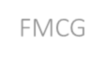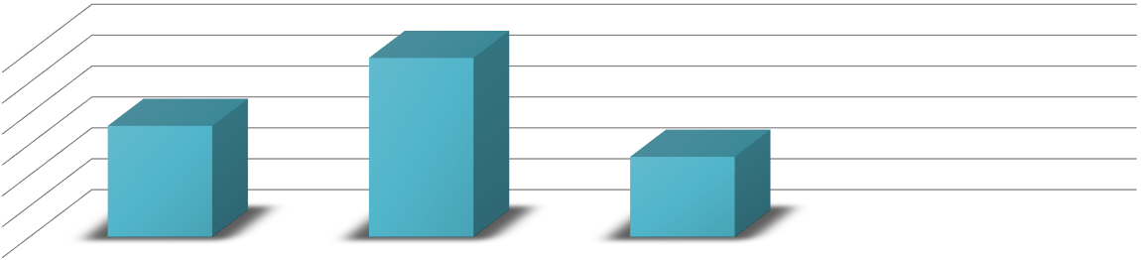





References -

* Wikipedia, < <https://en.wikipedia.org/wiki/Data_analysis>>
* Fidelity International, <https://www.fidelity.com.sg/beginners/what-is-volatility/market-volatility>
* Wallstreetmojo team, <https://www.wallstreetmojo.com/drawdown/>



THANK YOU